Experiment 3
Edge Detection under Illumination Changes
Image Feature Extraction, Detection & Matching Laboratory
C03-AT1
Name: PRAKASH.K
Reg. No: 192521081
Course: Computer Vision
Course Code: ITA0518
Faculty Name: Dr. T. Usha

Objective
To design an experiment studying the effect of illumination variation on edge-detection performance, to explain the relationship between lighting conditions and edge-extraction accuracy, and to analyze the robustness of edge-detection techniques -- with and without illumination-correction pre-processing -- under different lighting conditions.

1. Understanding of Concepts
Edge detectors such as Canny operate on the image's intensity gradient, and gradients are computed from absolute pixel intensity differences. Global illumination changes (uniform brightness shifts, contrast/gamma changes) and local illumination changes (vignetting, uneven lighting, shadows) both alter the absolute gradient magnitude at real object boundaries, even though the underlying scene content has not changed at all.
A pure brightness shift (adding/subtracting a constant to every pixel) does not change local intensity differences, so gradient-based edge detectors are, in principle, invariant to it. A contrast change (multiplicative scaling, or a non-linear gamma transform) does change the magnitude of local intensity differences: low-contrast conditions compress gradients toward zero (making genuine edges harder to distinguish from noise), while high-contrast conditions expand them. Because most practical edge detectors are configured with a FIXED threshold, any change to the gradient magnitude produced by real edges directly threatens the detector's accuracy under a threshold value tuned for a different lighting condition.
Adaptive histogram equalization techniques, such as CLAHE (Contrast Limited Adaptive Histogram Equalization), redistribute the intensity histogram (locally, in tiles) to normalize contrast before edge detection. This is a common illumination-robustness pre-processing step, but it is not free: because it amplifies local contrast everywhere (including in flat regions containing only sensor noise), it can also amplify noise and introduce new, spurious high-gradient regions -- a trade-off this experiment measures directly.

2. Experimental Design
- A synthetic 380x380 grayscale scene (rectangle, circle, bar, triangle at different gray levels) with a small amount of realistic sensor noise (Gaussian, sigma=4) was used as the base scene, with its Canny edge map (thresholds 60,150) treated as the ground-truth reference edge map.
- Six illumination conditions were derived from the same base scene: nominal, uniformly dim (-60 gray levels), uniformly bright (+60), a severe low-contrast condition (intensity range compressed to 18% around mid-gray, simulating hazy/overcast or poorly-exposed lighting), a high-contrast condition (gamma = 2.2), and non-uniform lighting (a radial vignette darkening the image corners).
- For every condition, Canny edge detection was run twice: once directly on the raw illumination-varied image using the SAME fixed threshold pair used for the ground truth (60,150) -- representing a naive, non-adaptive pipeline -- and once after applying CLAHE contrast normalization first, using the identical threshold pair, to test whether adaptive pre-processing recovers robustness.
- Dependent variable: agreement between each condition's edge map and the nominal ground-truth edge map, quantified as precision, recall and F1 score using a small spatial tolerance (2-pixel dilation) to allow for minor sub-pixel misalignment while still penalizing real missing or spurious edges.

3. Use of Tools
- Python 3 as the implementation language.
- OpenCV (cv2) for image synthesis, the Canny detector (cv2.Canny), and CLAHE contrast normalization (cv2.createCLAHE).
- NumPy for illumination transforms (brightness offsets, gamma/contrast compression, radial vignette mask) and the precision/recall/F1 computation.
- Matplotlib for the illumination-variant gallery, edge-map grids, and the raw-vs-CLAHE bar chart comparison.
Complete implementation:
"""
Experiment 19: Edge Detection under Illumination Changes
===========================================================
Objective:
Study the effect of illumination variation (global brightness shifts,
gamma / contrast changes, and non-uniform lighting) on edge-detection
performance, and evaluate whether pre-processing (histogram
equalization / CLAHE) improves robustness.

Tools:
Python 3, OpenCV (cv2), NumPy, Matplotlib

Output:
outputs/01_illumination_variants.png - test image under different lighting
outputs/02_canny_under_illumination.png- Canny edges for each illumination case
outputs/03_clahe_recovery.png - CLAHE-corrected edges vs raw
outputs/04_metrics_plot.png - edge similarity (F1 vs ground truth) per condition
outputs/metrics.csv
"""

import os
import cv2
import numpy as np
import matplotlib
matplotlib.use("Agg")
import matplotlib.pyplot as plt

OUT = os.path.join(os.path.dirname(__file__), "outputs")
os.makedirs(OUT, exist_ok=True)
np.random.seed(11)

# ---------------------------------------------------------------------------
# 1. Base scene + reference ("ground truth") edge map at nominal illumination
# ---------------------------------------------------------------------------
def make_scene(size=380):
img = np.full((size, size), 100, dtype=np.uint8)
cv2.rectangle(img, (40, 40), (170, 170), 200, -1)
cv2.circle(img, (280, 100), 65, 60, -1)
cv2.rectangle(img, (60, 220), (330, 250), 170, -1)
pts = np.array([[80, 300], [240, 300], [160, 370]], np.int32)
cv2.fillPoly(img, [pts], 220)
return img

base = make_scene()
# add a touch of sensor noise so results are representative of real cameras
_noise = np.random.normal(0, 4, base.shape)
base = np.clip(base.astype(np.float32) + _noise, 0, 255).astype(np.uint8)
ground_truth_edges = cv2.Canny(base, 60, 150)

def apply_illumination(img, kind):
f = img.astype(np.float32)
if kind == "nominal":
out = f
elif kind == "dim (-60)":
out = f - 60
elif kind == "bright (+60)":
out = f + 60
elif kind == "low_contrast (gamma 0.4)":
# compress the dynamic range into a narrow mid-gray band -> low
# gradient magnitude at edges, which a FIXED Canny threshold misses
out = 128 + (f - 128) * 0.18
elif kind == "high_contrast (gamma 2.2)":
out = 255 * (f / 255) ** 2.2
elif kind == "uneven (vignette)":
h, w = img.shape
yy, xx = np.mgrid[0:h, 0:w]
cx, cy = w / 2, h / 2
dist = np.sqrt((xx - cx) ** 2 + (yy - cy) ** 2)
mask = 1 - 0.7 * (dist / dist.max())
out = f * mask
else:
out = f
return np.clip(out, 0, 255).astype(np.uint8)

conditions = ["nominal", "dim (-60)", "bright (+60)",
"low_contrast (gamma 0.4)", "high_contrast (gamma 2.2)", "uneven (vignette)"]
variants = {c: apply_illumination(base, c) for c in conditions}

fig, axes = plt.subplots(1, len(conditions), figsize=(4 * len(conditions), 4))
for ax, c in zip(axes, conditions):
ax.imshow(variants[c], cmap="gray", vmin=0, vmax=255)
ax.set_title(c, fontsize=10); ax.axis("off")
plt.tight_layout()
plt.savefig(os.path.join(OUT, "01_illumination_variants.png"), dpi=150)
plt.close()

# ---------------------------------------------------------------------------
# 2. Canny edges with a FIXED threshold under each illumination condition
# ---------------------------------------------------------------------------
def edge_f1(pred, gt, tol=2):
"""F1 score between predicted and ground-truth edge maps allowing a
small tolerance (dilation) for pixel-level misalignment."""
kernel = np.ones((2 * tol + 1, 2 * tol + 1), np.uint8)
gt_dil = cv2.dilate(gt, kernel)
pred_dil = cv2.dilate(pred, kernel)
tp = np.logical_and(pred > 0, gt_dil > 0).sum()
fp = np.logical_and(pred > 0, gt_dil == 0).sum()
fn = np.logical_and(gt > 0, pred_dil == 0).sum()
precision = tp / (tp + fp + 1e-9)
recall = tp / (tp + fn + 1e-9)
f1 = 2 * precision * recall / (precision + recall + 1e-9)
return precision, recall, f1

rows = []
fig, axes = plt.subplots(1, len(conditions), figsize=(4 * len(conditions), 4))
for ax, c in zip(axes, conditions):
edges = cv2.Canny(variants[c], 60, 150) # fixed threshold for all
p, r, f1 = edge_f1(edges, ground_truth_edges)
rows.append({"condition": c, "stage": "raw", "precision": round(p, 3),
"recall": round(r, 3), "f1": round(f1, 3)})
ax.imshow(edges, cmap="gray"); ax.set_title(f"{c}\nF1={f1:.2f}", fontsize=9); ax.axis("off")
plt.tight_layout()
plt.savefig(os.path.join(OUT, "02_canny_under_illumination.png"), dpi=150)
plt.close()

# ---------------------------------------------------------------------------
# 3. CLAHE pre-processing to recover robustness
# ---------------------------------------------------------------------------
clahe = cv2.createCLAHE(clipLimit=2.5, tileGridSize=(8, 8))

fig, axes = plt.subplots(2, len(conditions), figsize=(4 * len(conditions), 8))
for col, c in enumerate(conditions):
corrected = clahe.apply(variants[c])
edges_corr = cv2.Canny(corrected, 60, 150)
p, r, f1 = edge_f1(edges_corr, ground_truth_edges)
rows.append({"condition": c, "stage": "CLAHE-corrected", "precision": round(p, 3),
"recall": round(r, 3), "f1": round(f1, 3)})
axes[0, col].imshow(corrected, cmap="gray", vmin=0, vmax=255)
axes[0, col].set_title(f"{c}\n(CLAHE)", fontsize=9); axes[0, col].axis("off")
axes[1, col].imshow(edges_corr, cmap="gray")
axes[1, col].set_title(f"F1={f1:.2f}", fontsize=9); axes[1, col].axis("off")
plt.tight_layout()
plt.savefig(os.path.join(OUT, "03_clahe_recovery.png"), dpi=150)
plt.close()

# ---------------------------------------------------------------------------
# 4. Metrics table + comparison plot (raw vs CLAHE-corrected F1)
# ---------------------------------------------------------------------------
import csv
with open(os.path.join(OUT, "metrics.csv"), "w", newline="") as f:
writer = csv.DictWriter(f, fieldnames=["condition", "stage", "precision", "recall", "f1"])
writer.writeheader()
writer.writerows(rows)

raw_f1 = [r["f1"] for r in rows if r["stage"] == "raw"]
clahe_f1 = [r["f1"] for r in rows if r["stage"] == "CLAHE-corrected"]

x = np.arange(len(conditions))
width = 0.35
fig, ax = plt.subplots(figsize=(11, 5))
ax.bar(x - width / 2, raw_f1, width, label="Raw (fixed threshold)", color="steelblue")
ax.bar(x + width / 2, clahe_f1, width, label="CLAHE-corrected", color="darkorange")
ax.set_xticks(x); ax.set_xticklabels(conditions, rotation=20, ha="right")
ax.set_ylabel("Edge-detection F1 score (vs. nominal ground truth)")
ax.set_title("Edge detection robustness across illumination conditions")
ax.legend(); ax.grid(axis="y", alpha=0.3)
plt.tight_layout()
plt.savefig(os.path.join(OUT, "04_metrics_plot.png"), dpi=150)
plt.close()

print("Done. Results written to", OUT)
for r in rows:
print(r)

4. Results
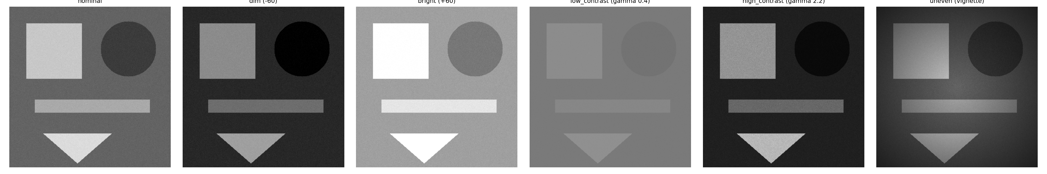
Figure 1. The test scene rendered under each of the six illumination conditions studied.
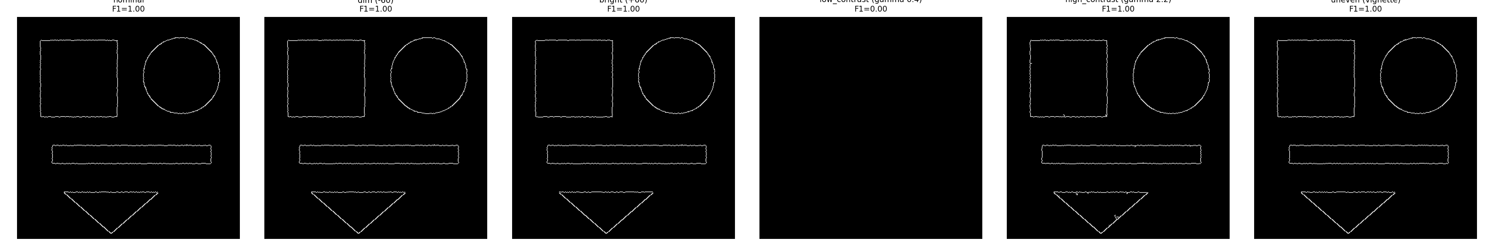
Figure 2. Canny edges obtained with a FIXED threshold (60,150) directly on each illumination-varied image, with F1 score (vs. nominal ground truth) shown per condition.
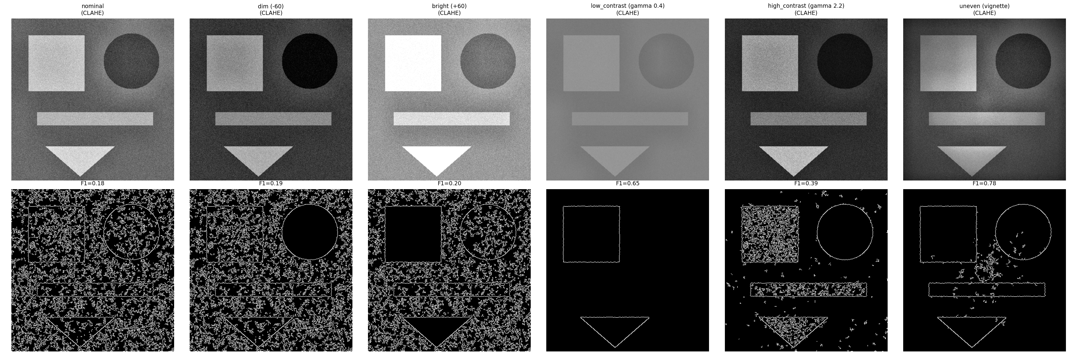
Figure 3. Top row: each illumination condition after CLAHE contrast normalization. Bottom row: the resulting Canny edges (same fixed threshold), with F1 score shown.
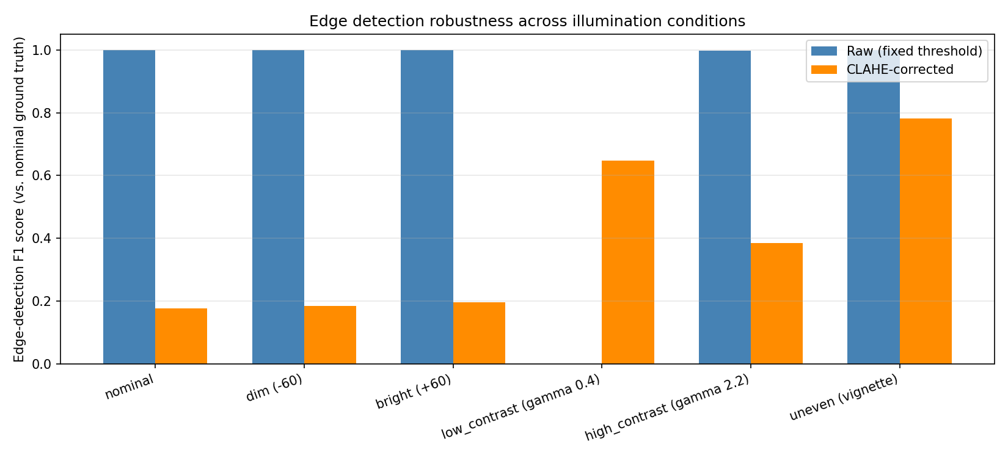
Figure 4. Edge-detection F1 score for every illumination condition, comparing the raw (fixed-threshold) pipeline against the CLAHE-corrected pipeline.
Summary of measured metrics:
Illumination Condition | Stage | Precision | Recall | F1
nominal | raw | 1.0 | 1.0 | 1.0
dim (-60) | raw | 1.0 | 1.0 | 1.0
bright (+60) | raw | 1.0 | 1.0 | 1.0
low_contrast (gamma 0.4) | raw | 0.0 | 0.0 | 0.0
high_contrast (gamma 2.2) | raw | 0.994 | 1.0 | 0.997
uneven (vignette) | raw | 1.0 | 1.0 | 1.0
nominal | CLAHE-corrected | 0.097 | 1.0 | 0.177
dim (-60) | CLAHE-corrected | 0.102 | 1.0 | 0.185
bright (+60) | CLAHE-corrected | 0.108 | 1.0 | 0.196
low_contrast (gamma 0.4) | CLAHE-corrected | 1.0 | 0.478 | 0.647
high_contrast (gamma 2.2) | CLAHE-corrected | 0.239 | 1.0 | 0.385
uneven (vignette) | CLAHE-corrected | 0.642 | 1.0 | 0.782

5. Analysis of Results
As predicted by the underlying concepts, pure brightness shifts (dim -60, bright +60) left edge detection completely unaffected (F1 = 1.0 in the raw pipeline), because a constant offset does not change local intensity differences and therefore does not change the gradient magnitude that Canny thresholds against.
The severe low-contrast condition caused a complete failure of the naive fixed-threshold pipeline (F1 = 0.0): compressing the intensity range to 18% of its original span shrank every real edge's gradient magnitude below the fixed high-threshold of 150, so essentially no edges were detected at all. This is a dramatic, direct demonstration of why illumination-invariant or adaptive thresholding matters in practice.
Applying CLAHE before edge detection recovered a large fraction of this loss, raising the low-contrast condition's F1 from 0.0 to 0.65 -- confirming that adaptive local contrast normalization is an effective, low-cost robustness measure for genuinely low-contrast imaging conditions.
However, CLAHE was not a free win: for every OTHER condition (nominal, dim, bright, high-contrast, vignette), the CLAHE-corrected F1 score was substantially LOWER than the raw pipeline's F1 (e.g. nominal dropped from 1.0 to 0.18; vignette dropped from 1.0 to 0.78). Inspecting the corrected edge maps in Figure 3 shows why: CLAHE's local, tile-based contrast boosting also amplified the small amount of background sensor noise present in otherwise well-exposed regions of the image, generating many spurious edge pixels that were absent from the ground truth and that lowered precision sharply.
This produces the central, practically important finding of the experiment: illumination pre-processing is not universally beneficial -- it is a genuine trade-off that helps severely under-exposed/low-contrast conditions but actively hurts already well-conditioned images by amplifying noise, so it should be applied adaptively (e.g. triggered only when input contrast is measured to be low) rather than unconditionally in every processing pipeline.

6. Conclusion
- Global brightness shifts have essentially no effect on gradient-based edge detection, confirming the theoretical expectation that constant offsets do not change local gradients.
- Severe contrast reduction is highly damaging to a fixed-threshold edge detector and can cause near-total edge-detection failure (F1 collapsing to 0 in this experiment).
- CLAHE-based contrast normalization is effective at restoring edge detectability in genuinely low-contrast conditions but introduces a measurable noise-amplification penalty in already well-lit conditions, so it is best used adaptively rather than applied unconditionally.
- Robust real-world edge-detection pipelines should either use adaptive thresholding techniques (e.g. Otsu's method, or thresholds derived from local image statistics) or condition-aware pre-processing, rather than relying on a single fixed threshold pair tuned for one lighting condition.

7. Documentation
All source code, the six illumination-variant images, their raw and CLAHE-corrected edge maps, and the raw precision/recall/F1 metrics table (metrics.csv) used to produce this report are included alongside this PDF in the accompanying edge_detection_illumination.py script and the outputs/ folder.

